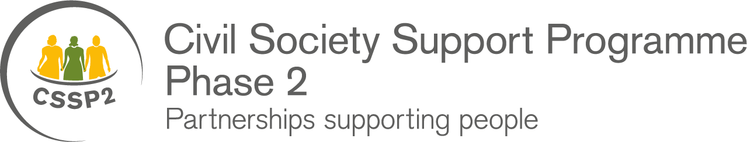

**Civil Society Support Programme Phase Two (CSSP2) for Local Action Grants**

**Proposal Application Form**

Name of Applicant: ____________________________

Project title: __________________________________

July 2022

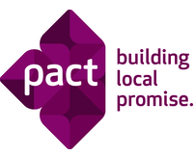

Addis Ababa





**SECTION ONE: APPLICANT INFORMATION**

|  |  |
| --- | --- |
| LEAD APPLICANT | |
| **Name of the Applicant** |  |
| **Organisation type[1]** |  |
| **Year of establishment** |  |
| **Registration number** |  |
| **Registering/Licencing government body** |  |
| **Head Office Address** |  |
| * Office Telephone number |  |
| * E-mail |  |
| * P.O.Box |  |
| * Region/City/Woreda/Kebele |  |
| **Head of the Organisation** |  |
| * Name |  |
| * Mobile number |  |
| * E-mail |  |
| **Contact Person** |  |
| * Name |  |
| * Mobile number |  |
| * E-mail |  |

**SECTION TWO: PROJECT INFORMATION**

|  |  |
| --- | --- |
| 1. Project Description | |
| * 1. **Intervention areas (should fall under one of the three thematic and sub thematic areas of CSSP2)**   **[Please refer the guideline]** |  |
| * 1. **Title of the Project:** |  |
| * 1. **Project Summary:** *Concise summary of the project in half a page, providing the snapshot of the issue and context, target groups, expected results and corresponding activities* | |
|  | |
| * 1. **Project Location (Region, Zone, Woreda and Kebele)** |  |
| * 1. **The context (max 1 page)**  1. *Provide well supported analysis of the issues and the context in which the project is going to be implemented including its gender, disability, social inclusion and human rights dimensions at local level (how the* *issue/problem affects women/girls, boys &men, persons with disabilities, and other marginalized groups vis-a-vis the promotion and protection of their human rights). Please provide* *evidence-based and detailed analysis of the context in which the project is going to be implemented and how it affects your project*   ***[Refer the CSSP2 thematic areas diagram that is available at the end of this document]*** | |
|  | |
| * 1. **Relevance of the Project (max 1 page)**  1. *Relevance of intervention in responding to the issues and the context, including how it will respond to the specific gendered, disability, social inclusion, and human rights aspects i.e. (how will the project address barriers for women, men, girls, boys, persons with disabilities and other marginalized groups vis-à-vis the promotion and protection of the human rights issue being addressed)* 2. *Alignment of interventions to the priorities of CSSP2 (in link with CSSP2 theory of change).* ***[Refer the CSSP2 theory of Change from the Grant guideline. The diagram form of the theory of change is also available at the end of this document]*** | |
|  | |
| * 1. **Objectives and Results (max 1.5 pages)**  1. *Discuss the overall and specific objectives of the project* 2. *Clearly state the project outputs devoted to addressing the barriers and constraints identified in the problem/context analysis for women, persons with disabilities and other vulnerable groups in relation with the issue with description of corresponding activities and their feasibility in the current context* 3. *How does the proposed intervention and anticipated changes improve the situation and specific vulnerabilities of women, the poorest, PWD and other relevant vulnerable social groups at local level* 4. *Clearly state the targets and result measurement indicators for each output (targets could be both people and organisation or either of them)* 5. *Describe how the project contributes to CSSP2’s outcomes and/or output areas.* ***[Please refer to the results framework annexed at the end of this document****].* | |
|  | |
| * 1. **Discuss the human rights-based approach underlying the project strategy (max ½ page)** | |
|  | |
| * 1. **Discuss key stakeholders, their roles, and your engagement strategies (max 1 page).** *Ensure that your application also discusses how your engagement strategies (with constituency, beneficiaries, government, and other relevant stakeholders at local level) are aligned to the gendered, disability, social inclusion barrier analysis you’ve identified in the context analysis.* | |
|  | |
| * 1. **Target Groups**  1. *Define the number and describe your direct target groups disaggregated by gender, disability, and other factors of diversity. If targets are organizations, discuss the type of organizations targeted.* 2. *Provide indicative number of the indirect target groups disaggregated by gender, disability and other factors of diversity including how the interventions will indirectly address their needs and priorities.* | |
|  | |
| * 1. **Risks and Assumptions:** *provide analysis of possible risks to the project including how they affect the project activities and results with mitigation measures. Identified risks should be project and context specific* | |
|  | |
| * 1. **Safeguarding:** w*hat steps are you taking to ensure the safety of children and adults at-risk that will come into contact with your project and staff? Please mention what mechanisms and tools your organisation has put in place to ensure the safety of these groups?* | |
|  | |
| * 1. **Sustainability and/or potential for scaleup**: Discuss the sustainability of the action as well as the potential for scaleup either for higher-level results or in new geographical and thematic areas. | |
|  | |

**SECTION THREE: WORK PLAN**

|  |  |
| --- | --- |
| Project Duration | **8 months max (from Date/Month/Year to Date/Month/Year** |
| Detailed Workplan | |
| The workplan plan should present all activities of the project with detailed sub-activities and implementation period by month. Complete the standard workplan template in **Annex 2**. | |

**SECTION FOUR: BUDGET PLAN**

|  |  |
| --- | --- |
| Total Project Budget in Ethiopian Birr | **[refer the guideline for budget range]** |
| Detailed Budget | |
| Budget plan should present the **summary** and **detailed budget** items and their corresponding costs. Budget should be presented in Ethiopian Birr.  Complete the standard detailed budget template in **Annex 3 and the summary in the following table.** | |
| Other Source Finance | |
| Indicate finance requested and secured from other sources/donors for the same project (if any) to support all or part of the planned activities. | |
| **Budget Summary**   |  |  |  |  |  | | --- | --- | --- | --- | --- | | S.N | Description (activities & other budget items) | Operational (≥80%) | Administrative (≤20%) | Total (ETB) | |  |  |  |  |  | |  |  |  |  |  | |  |  |  |  |  | |  |  |  |  |  | |  |  |  |  |  | | |

**SECTION FIVE: CONFLICT OF INTEREST DECLARATION**

|  |
| --- |
| DECLARATION |
| Please complete **Annex 4** if any potential conflict of interest with Civil Society Support Programme Phase 2 (CSSP2) intervention which might arise as a result of:   * Executive directors or board members holding jobs or responsibilities at CSSP2 * Other funding sources (current or forecast) you received or expect for the same intervention. * Any other activities that the organisation is undertaking or is expecting to undertake |

**SECTION SIX: APPLICATION CHECKLIST**

Before sending your application pack, please check that each of the below criterion has been met in full

|  |  |  |  |
| --- | --- | --- | --- |
| **Descriptions** | **Yes** | **No** | **If it is not applicable (N/A), Why?** |
| 1. Have you used the proper CSSP2’s Proposal Application Form for Local Action Grants? |  |  |  |
| 1. Have you included completed Work Plan template? |  |  |  |
| 1. Have you included completed Budget? |  |  |  |
| 1. Have you included completed Monitoring Plan template ? |  |  |  |
| 1. Have you included Signed and stamped declaration form? |  |  |  |
| 1. Have you followed the guidance given under Local Action Grant application guideline? |  |  |  |
| 1. Make sure that you are submitting your full proposal application pack in soft copy via e-mail address provided in this application form. |  |  |  |
| 1. Make sure that you are submitting safeguarding policy |  |  |  |

**Annex I**

**CSSP2 Theory of Change**

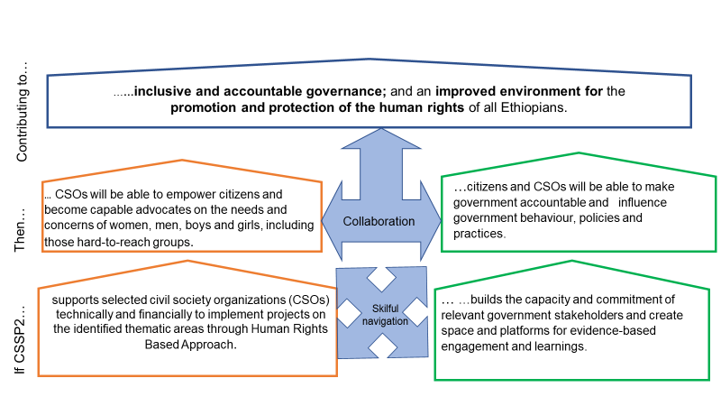

**Annex II**

**CSSP2 Results Framework**

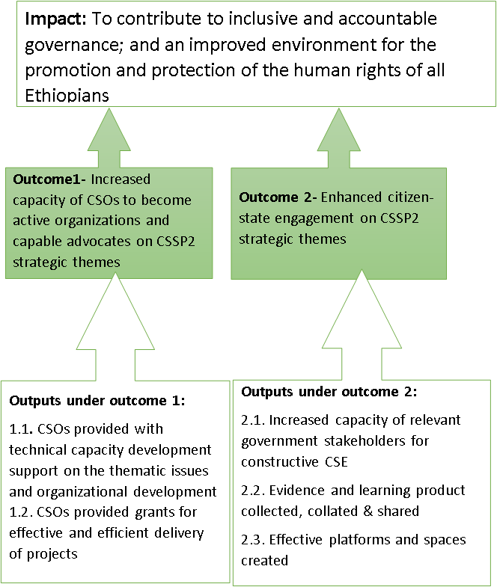

**Annex III**

**CSSP2 Strategic Themes**

**Gender**

**Transformation**

**Young People**

**Citizen-State**

**Engagement**

Gender based violence

Land rights

Political participation

Substance abuse

Decent work

Youth voice

Social minorities

inclusion

Stronger, better CSOs

Trust and confidence

1. As indicated on your registration certificate, specify the type of your organization. e.g. CSO, network, association, government entity, private sector etc